The Free 2007/2010 Microsoft Word Mathematics Add-In
Gail Nord
Gonzaga University
Spokane, WA, 99258, USA
nord@gonzaga.edu

Number Theory

Example 1: Find the remainder when 21 is divided by 5.

$$21 mod 5$$
$$1$$

Example 2: Find the greatest common factor from a list of numbers.

$$gcf 300,145$$

$$5$$

Example 3: Convert the following number that is given in base 10 to a base of 3.
35
Our example will be:
$$toBase(3,35)$$
The result is:
$${1022}_{3}$$

Example 4: Convert a number from another base to base ten.
$${1022}_{3}$$
The original base must be a number between 2 and 36. Our example will be:
$$base(3,1022)$$
$$35$$
Example 5: From a list, find a maximum value.
$$\{2,.3,7,56.22,4\}$$

Example 6: Given a number, find the closest prime to the right of it.
$$104$$

$$nextPrime(104)$$
$$107$$
$$PrevPrime(104)$$

Example 7: Determine if a given number is a prime number.
$$107$$
The command is IsPrime. The input will be:
$$IsPrime(107)$$
$$true$$

Example 8: Give the prime factorization for a given integer.
$$2200$$

$$factor(2200)$$
$$2^{3}·5^{2}·11$$

Graphing

Graphing Commands
Flexible input allows for alternative syntax.
$$plot2d(4x^{2}+12x+2)$$

$$4x^{2}+12x+2$$

$$y=4x^{2}+12x+2$$

Example 1:
Consider the graphs of the roses generated by:
$r=cos⁡(n θ)$

$plotPolar2d\left(\cos\left(nθ\right)\right)$

Example 2: Graphing in three dimensions:

$plotPolar3D\left(\cos\left(3θ\right)\sin\left(2φ\right) \right)$

Example 3:
Graph:
$$r=θφ$$

$$θφ$$

$$plotpolar3d(θφ)$$
Command | Example | Input
Plot2d | $$plot2d(4x^{2}+12*x+2)$$ | Input function, f(x).
plot3D | $$plot3D(2x+y^{3})$$ | Input where, z=f(x, y).
plotCylR3D | $$plotCylR3D(r^{2}+\sin\left(2θ\right))$$ | Input z=f(r, $θ).$
plotEq2d | $$plotEq2d(x^{2}+y^{2}=4)$$ | Input f(x, y) = c.
plotEq3D | $$plotEq3D(\frac{x^{2}}{9}+y^{2}+z^{2}=1)$$ | Input f(x, y, z)=c.
plotIneq2d | $$plotIneq2d(2x≤3+3y)$$ | Input inequality in x and y.
plotParam2d | $$plotParam2d(\sin{t, 3t-5)}$$ | Input (f(t), g(t)) where x=f(t) and y=g(t).
plotParam3D | $$plotParam3D(t+s^{2}, t+3s, t-s^{2})$$ | Input (f(t, s), g(t, s),  h(t, s)) where x=f(t, s) and  y=g(t, s) and z=h(t, s).

To execute these commands using the drop-down menu, apply Calculate.

Example 4: Use the Show3D command.

$$show3d\left(Ploteq3d\left(x^{2}+y^{2}=1\right),ploteq3d\left(z^{2}+y^{2}=1\right)\right)$$

Example 4b:

$$show3d(plot3D\left(x^{2}+y^{2}\right),plot3D\left(x-y\right))$$

Example 5: Use the Show2D command.

$$show2d(Plot2d\left(x^{3}\right),Plot2d((deriv\left(x^{3},x\right)))$$

Example 6: Create a movie.
$z=x^{2}+{(-1)}^{ceiling a} y^{2}/4$

The two quadric surfaces that will alternatively appear will be a hyperbolic paraboloid and an elliptic paraboloid.

Example 7: Create an animated spring.
(Works in Mathematics 4.0—but not here)

$$show3D(plotParamLine3d\left(a t,b sin\left(t\right),c cos\left(t\right)\right),plotParamLine3d(t,\sin\left(t\right),\cos\left(t\right))$$

Linear Algebra
Vectors and Matrices

Use the Matrix feature.

Example 1: Add two vectors.
$$\left(\begin{matrix}1 \\ 2 \\ 3\end{matrix}\right)+\left(\begin{matrix}4 \\ -5 \\ 3\end{matrix}\right)$$
Calculate gives the resultant vector,
$$\left(\begin{matrix}5 \\ -3 \\ 6\end{matrix}\right)$$
Example 2: Find the magnitude of a vector.

$$magnitude(\left\{3,-2,1\right\})$$
Use the command Calculate to find the answer:
$$\sqrt{14}$$

Example 3: Find the inner product.
$$inner(\left\{3,-2,1\right\},\left\{5,0,2\right\})$$

$$17$$

Example 4: Find the cross product where $A=<-2, 4, 5>$ and $B=<3, 2, 1>.$

$$cross(\left\{-2,4,5\right\},\left\{3,2,1\right\})$$
$$\left\{-6, 17, -16\right\}$$

Example 5: Calculate the determinant of a
3 x 3 matrix.
$$\left(\begin{matrix}1 & 1 & 2 \\ 2 & -2 & 4 \\ -3 & 3 & 6\end{matrix}\right)$$
$$-48$$

Using the other options, find the trace of the matrix is 5, the inverse matrix is $\left(\begin{matrix}\frac{1}{2} & 0 & -\frac{1}{6} \\ \frac{1}{2} & -\frac{1}{4} & 0 \\ 0 & \frac{1}{8} & \frac{1}{12}\end{matrix}\right)$
and the transpose of the matrix is $\left(\begin{matrix}1 & 2 & -3 \\ 1 & -2 & 3 \\ 2 & 4 & 6\end{matrix}\right)$.

Example 6: Given a 3 x 3 matrix and its inverse, show the product gives the identity matrix.
$$\left(\begin{matrix}\frac{1}{2} & 0 & -\frac{1}{6} \\ \frac{1}{2} & -\frac{1}{4} & 0 \\ 0 & \frac{1}{8} & \frac{1}{12}\end{matrix}\right)\left(\begin{matrix}1 & 1 & 2 \\ 2 & -2 & 4 \\ -3 & 3 & 6\end{matrix}\right)$$

Example 7: Find the Boolean product of${\left(\begin{matrix}0 & 0 & 1 \\ 1 & 0 & 0 \\ 1 & 1 & 0\end{matrix}\right)}^{3}$.

There are a few ways to do this. For one approach, enter the 3 x 3 matrix $\begin{matrix}0 & 0 & 1 \\ 1 & 0 & 0 \\ 1 & 1 & 0\end{matrix}$ and do not press Calculate. The insertion of a pasted object with spaces or parentheses often gives an error message. Without pressing Calculate, the matrix, $\begin{matrix}0 & 0 & 1 \\ 1 & 0 & 0 \\ 1 & 1 & 0\end{matrix}$ will contain no parentheses. Cut and paste this matrix and place as the ‘base’. Insert the three as a superscript using this feature:
The command Calculate from the drop-down menu gives the desired result of:
$$\left(\begin{matrix}1 & 0 & 1 \\ 1 & 1 & 0 \\ 1 & 1 & 1\end{matrix}\right)$$
The superscript may be toggled to be 7, and the new Boolean product can be found to be:
${\begin{matrix}0 & 0 & 1 \\ 1 & 0 & 0 \\ 1 & 1 & 0\end{matrix}}^{7}$=$\left(\begin{matrix}3 & 2 & 2 \\ 2 & 1 & 2 \\ 4 & 2 & 3\end{matrix}\right)$
Another approach is to enter the matrix and superscript directly without cutting and pasting to give: ${\begin{matrix}0 & 0 & 1 \\ 1 & 0 & 0 \\ 1 & 1 & 0\end{matrix}}^{3}$
If there is a desire for the parentheses to be displayed, enter the matrix and then press Calculate to give:
$$\left(\begin{matrix}0 & 0 & 1 \\ 1 & 0 & 0 \\ 1 & 1 & 0\end{matrix}\right)$$
With the cursor inside the blue box, press ^3 followed by a space bar.
This will move the three to the desired location and give:
$${\left(\begin{matrix}1 & 0 & 1 \\ 1 & 0 & 0 \\ 1 & 1 & 0\end{matrix}\right)}^{3}$$
Press Calculate to simplify.

Example 8: Reduce a 3 x 3 matrix to row reduced echelon form.
$$\left(\begin{matrix}6 & 3 & -4 \\ -4 & 1 & -6 \\ 1 & 2 & -5\end{matrix}\right)$$

$$\begin{matrix}6 & 3 & -4 \\ -4 & 1 & -6 \\ 1 & 2 & -5\end{matrix}$$
Press Calculate to obtain the parentheses.
$$\left(\begin{matrix}6 & 3 & -4 \\ -4 & 1 & -6 \\ 1 & 2 & -5\end{matrix}\right)$$
$$reduce\left(\begin{matrix}6 & 3 & -4 \\ -4 & 1 & -6 \\ 1 & 2 & -5\end{matrix}\right)$$
$$\left(\begin{matrix}1 & 0 & \frac{7}{9} \\ 0 & 1 & -\frac{26}{9} \\ 0 & 0 & 0\end{matrix}\right)$$
Example 9: Reduce the matrix to row reduced echelon form.
$$\left(\begin{matrix}1 & -2 & 3 & -1 \\ 2 & -1 & 2 & 2 \\ 3 & 1 & 2 & 3\end{matrix}\right)$$

There is a problem entering this size of matrix from the menu since it is larger than a 3 x 3 matrix.

$$\left\{1,-2,3,-1\right\},\left\{2,-1,2,2\right\},\{3,1,2,3\}$$

Calculate will place { } around the input.
$$\left\{\left\{1, -2, 3, -1\right\}, \left\{2, -1, 2, 2\right\}, \left\{3, 1, 2, 3\right\}\right\}$$

With the cursor in the blue box, type matrix
Type in here matrix.

$$matrix\left\{\left\{1, -2, 3, -1\right\}, \left\{2, -1, 2, 2\right\}, \left\{3, 1, 2, 3\right\}\right\}$$

$$\left(\begin{matrix}1 & -2 & 3 & -1 \\ 2 & -1 & 2 & 2 \\ 3 & 1 & 2 & 3\end{matrix}\right)$$

$$reduce\left(\begin{matrix}1 & -2 & 3 & -1 \\ 2 & -1 & 2 & 2 \\ 3 & 1 & 2 & 3\end{matrix}\right)$$

$$\left(\begin{matrix}1 & 0 & 0 & \frac{15}{7} \\ 0 & 1 & 0 & -\frac{4}{7} \\ 0 & 0 & 1 & -\frac{10}{7}\end{matrix}\right)$$

Example 10: Find the inverse of a matrix.
If the matrix is a 2 x 2 or 3 x 3 matrix, the pull-down menu will contain the option, Invert Matrix.

However, for larger matrices the option will appear with the command, matrix, in the Insert New Equation line.
Enter each row of the matrix as a string using { and }. Separate the elements with a comma.
Consider the matrix$,$
$$\left(\begin{matrix}2 & 5 & -3 & -2 \\ -2 & -3 & 2 & -5 \\ 1 & 3 & -2 & 2 \\ -1 & -6 & 4 & 3\end{matrix}\right)$$
To enter the matrix, type:
$$\left\{\left\{2,5,-3,-2\right\},\left\{-2,-3,2,-5\right\},\left\{1,3,-2,2\right\},\left\{-1,-6,4,3\right\}\right\}$$
Place the cursor in the blue box and in front of the desired matrix.
Type matrix.
$$matrix\left\{\left\{2, 5, -3, -2\right\}, \left\{-2, -3, 2, -5\right\}, \left\{1, 3, -2, 2\right\}, \left\{-1, -6, 4, 3\right\}\right\}$$
With the insertion of matrix, the pop-up box changes and the desired option of Invert Matrix appears.

The answer is:
$$\left(\begin{matrix}0 & -\frac{7}{4} & -\frac{13}{4} & -\frac{3}{4} \\ 2 & \frac{17}{4} & \frac{31}{4} & \frac{13}{4} \\ 3 & \frac{23}{4} & \frac{41}{4} & \frac{19}{4} \\ 0 & \frac{1}{4} & \frac{3}{4} & \frac{1}{4}\end{matrix}\right)$$

Example 12: Solve a system of linear equations.
$$2x+6y-z=7$$
$$x+2y-z=-1$$
$$5x+7y-4z=9$$
Type each equation in a separate Insert New Equation line. If the last equation had no term of 7y, then a place-holder of 0y would have been needed. Now, highlight all three and right-click. The menu is:
The answer is:
$$\left\{\begin{aligned} x&=12 \\ z&=11 \\ y&=-1\end{aligned}\right.$$

As a matrix the answer is:
$$\left(\begin{matrix}1 & 0 & 0 & 12 \\ 0 & 1 & 0 & -1 \\ 0 & 0 & 1 & 11\end{matrix}\right)$$

Calculus
Example 1: Given a polynomial, find the 3rd derivative with respect to x.
Consider the input:
$$derivn(2x^{5}-2x, x, 3)$$

The same output can be obtained with an initial input of an expression:
$$2x^{5}-2x$$

Example 2: Differentiate.
$$arccos⁡(x-3)$$
Example 3: Integrate.

$$\sqrt{4-x^2}$$

Example 4: Evaluate the integral.
$$\int_{4}^{6}{x}\sqrt{x-3} dx$$
$$integral(x\sqrt{x-3},x,4,6)$$

$$-\frac{4·3^{\frac{5}{2}}}{15}+12 \sqrt{3}-\frac{12}{5}$$
Select Calculate to give:
$$14.2276877526612$$

More Information
Microsoft Corporation, Microsoft Mathematics Add-In for Word and OneNote (2010): http://www.microsoft.com/downloads/en/details.aspx?FamilyID=CA620C50-1A56-49D2-90BD-B2E505B3BF09
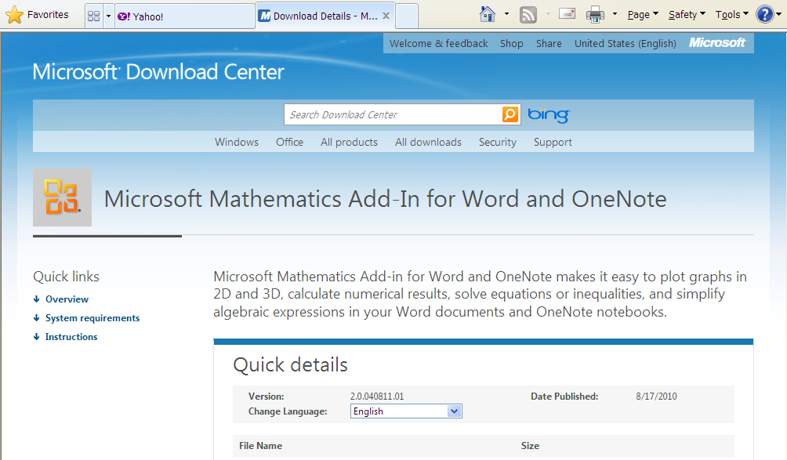

Reference
Gail Nord’s Website:

http://web02.gonzaga.edu/faculty/nord/

