Microsoft Mathematics 4.0 and Microsoft Word Mathematics Add-In
Professor Gail Nord
Gonzaga University, Spokane, WA, 99258, USA
nord@gonzaga.edu
http://web02.gonzaga.edu/faculty/nord/
509-313-3907

Microsoft Corporation, Microsoft Mathematics 4.0 (2011): http://www.microsoft.com/downloads/en/details.aspx?FamilyID=9CACA722-5235-401C-8D3F-9E242B794C3A
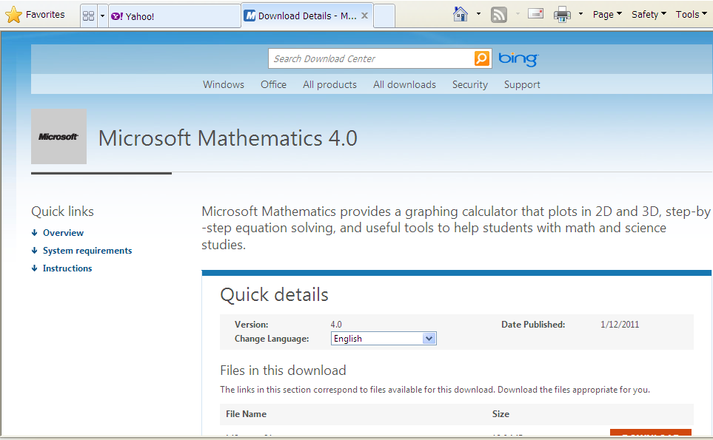
Download Location

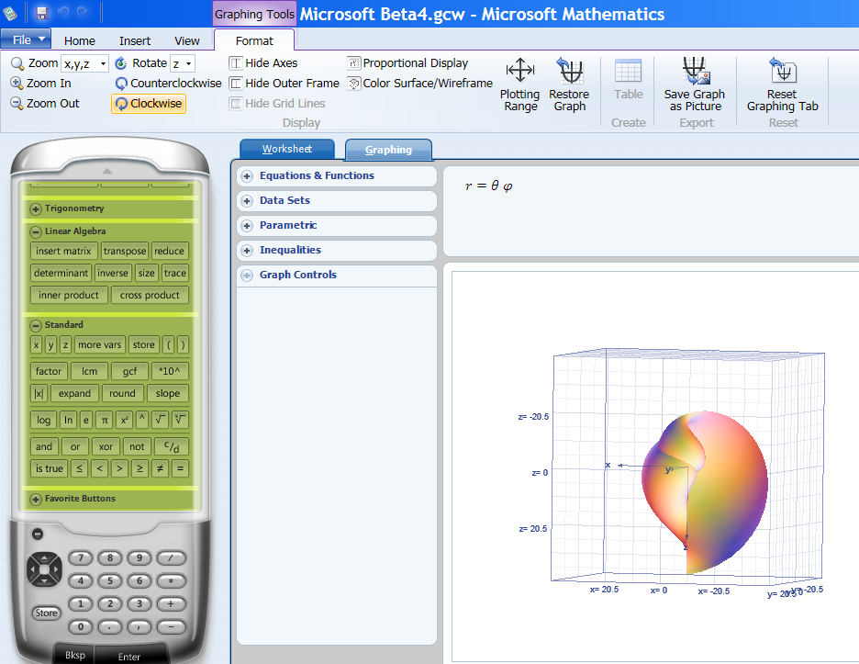
Interface

Microsoft Corporation, Microsoft Mathematics Add-In for Word and OneNote (2010): http://www.microsoft.com/downloads/en/details.aspx?FamilyID=CA620C50-1A56-49D2-90BD-B2E505B3BF09
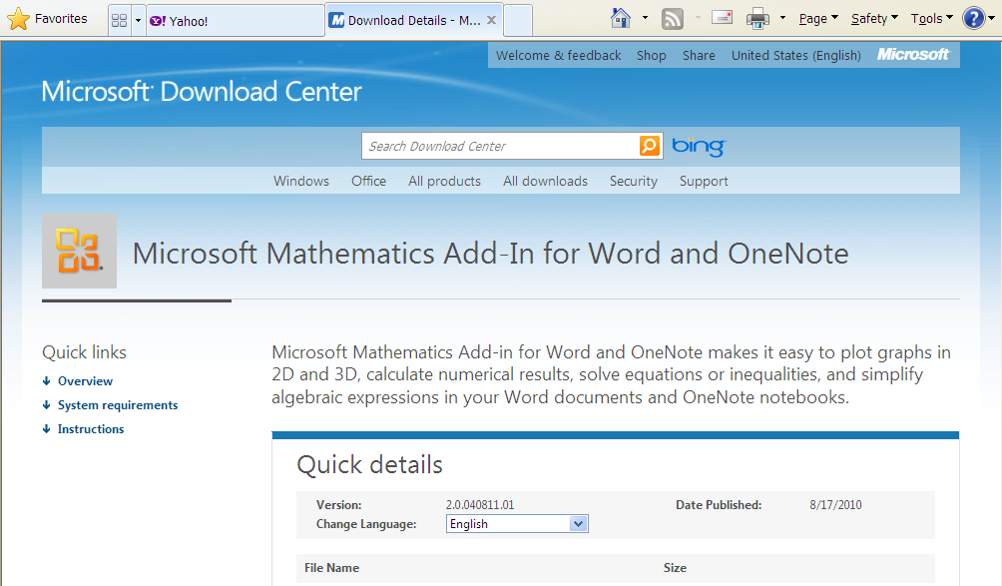
Download Location

Ribbon with Mathematics Tab

Insert New Equation Prompt

