The Microsoft Word Free Mathematics Add-In and Microsoft Mathematics Beta 4.0

Gail Nord
Department of Mathematics, Gonzaga University
Spokane, WA, 99258, USA

and

John Nord
Department of Mathematics, Saint George’s School
Spokane, WA, 99208, USA

ABSTRACT

This paper explores the use of powerful, free computer algebra system (CAS) software for the K-12 and university science, technology, engineering and mathematics (STEM) classrooms. Educational institutions are sorely in need of affordable technology. The financial reality facing many schools prohibits the allocation of limited resources for appropriate mathematical software. The free mathematics add-in offered to license holders of Microsoft Word 2007 and 2010 offers a prudent solution to this challenge. With particular strengths of graphing in two- and three-dimensions, Word’s add-in is a viable choice. Recently released, Microsoft Mathematics Beta 4.0 includes a full-featured, virtual graphing calculator designed to work just like a handheld calculator. Additional math tools help users evaluate triangles, convert from one system of units to another, and solve systems of equations. This software is free to all users. Graphics and mathematics results can be inserted into text documents from either program.

Keywords: Undergraduate Mathematics, Technology Integration, Computer Algebra System, Free Software Download and Microsoft.

1. INTRODUCTION
This paper is based on the presentation made in Denver, Colorado at the 2010 International Society for Technology in Education (ISTE) conference. ISTE hosts the largest educational technology exhibit in the United States. Feedback from mathematics educators and information technology personnel verified there is a need for technology access aimed at engaging students in STEM education. In testimony before the Congress, the Deputy Secretary of Education, Madeleine Kunin, said, “Our task, as you noted, with the budget deficit, is to use our limited resources in the most targeted and effective way, so that we can not only meet the technology needs of this country, but also meet the over-arching mission of the U.S. Department of Education, which is to improve access to high-quality education for all of America’s school children” [2]. The challenge is particularly large in communities facing budgeting shortfalls, with the greatest need frequently found in the communities least able to afford commercial solutions. Conference attendees offered anecdotal comments regarding their specific purpose at the conference. They sought free interactive technologies that could be brought back to their school districts. Some professionals were seeking solutions to target particular students, but many were just looking for any remedy that would promote inclusion of technology in the classroom.
The examples presented here are centered on improving the teaching and learning of two- and three-dimensional graphs using polar and spherical coordinates. The use of the animate command found within the free mathematics add-in is demonstrated and developed as a tool to aid discovery-style lessons. These sample examples would be conducive to whole class teaching, particularly if presented on Interactive Whiteboards (IWB).

2. MICROSOFT FREE MATHEMATICS ADD-IN

Set against this background, the use of the free mathematics add-in for Microsoft Word is a practical solution for schools without the budget-base that would allow for access to Mathematica, Maple, or other fee based CAS. To get started, download the free mathematics add-in from Microsoft [6]. Fig. 1 shows the placement in the ribbon.

Figure 1: Ribbon.

After pressing Insert New Equation, students are ready after one step to input an equation, expression, or inequality as shown in Fig. 2.

Figure 2: Insert new equation.

The screen is user-friendly and requires little or no training to enter the desired mathematical notation as shown in Fig. 3.

Figure 3: Navigation screen for input of mathematical notation.

3. EXAMPLES OF POLAR GRAPHS IN TWO-DIMENSIONS

Consider the graphs of the roses generated by:

$r=cos⁡(n θ)$.
The graphics package found within the mathematics add-in takes the command syntax:
$plotPolar2d(\cos{(nθ)})$
The content sensitive ‘right click’ generates a mathematical operations menu that contains, Compute. Animate appears as an option in the pop-up Microsoft Math Graph Controls dialogue box. Animate can be used to generate a movie of different roses as n changes, or n can be directly controlled by changing the value of the upper limit on the right of the animate control panel that allows input for a fixed value as shown in Fig. 4.

Figure 4: A rose where n is fixed for the frame.
The students can interact with the upper limit to generate real-time examples and quickly seize upon the theorem for roses. The number of petals is n if n is odd and 2n if n is even where $r=\sin{nθ}$ or $r=\cos{nθ}$ [10]. The plotPolar2d command can be absent, and an example using $r=\sin{nθ}$ is given in Fig. 5 using the Plot in 2D option from the pull-down screen. The input can merely be $\sin{nθ}$ followed by a right click. The input does not require multifaceted syntax. The animate command will appear by default with the introduction of the parameter, n.
Figure 5: Creating a movie with the right arrow key.
The polar graphs have angles defined in radians and are controlled by the Mathematics tab as shown in Fig. 6.
Figure 6: Math preferences.
Cardioids and limaçons can easily be treated with the same student interest generated by the Animate command. Apply the Compute option from the command, $plotPolar2d(a+b cos⁡(θ))$ and generate a graph with default values a = b = 1. For example, b = 1, when animating on a. It is possible to introduce more than one parameter for utilization of the animate feature.

Figure 7: Cardioid.
Students can discover that $r=a+bcosθ$ is the graph of a cardioid if |a| =|b| as shown in Figure 7. Otherwise, the graph is a limaçon that has two loops if |a| <|b|, dimpled if 1 < |$\frac{a}{b}$| 2, and convex if |$\frac{a}{b}$| 2 [10].

Several real-time examples involving the ‘play’ button will lead students to conjecture and test assumptions about the relationships between parameters a, and b, and the resulting graphs. Serious students looking for extensions, or explorations, can be left to discover relationships between graph types when parameters, a, b, and n, vary with the equation of $r=a+bcos nθ$ The speed of computers enables students to produce many examples when exploring mathematical problems; this supports their observation of patterns and the building and justifying of generalizations [9].

4. EXAMPLES OF POLAR GRAPHS IN THREE-DIMENSIONS
The free mathematics add-in found in Microsoft Word can also generate three-dimensional polar images, using spherical coordinates. An example of the syntax for three-dimensional polar graphs is $plotPolar3D\left(\cos\left(3θ\right)\sin\left(2φ\right)\right)$ . The image is shown in Fig. 8.

Figure 8: A three-dimensional image.
The National Council of Teachers of Mathematics encourages the use of graphing utilities to investigate informally the surfaces generated by functions of two variables. “Such investigations not only contribute to further development of important visualization skills but also foreshadow more advanced work with functions” [7].

An application of the animate command to three-dimensional polar graphs could entail using
$plotPolar3D\left(\cos\left(aθ\right)\sin\left(bφ\right)\right)$or$plotPolar3D(φcos\left(aθ\right))$. Similarly, the option of omitting the plotPolar3D syntax is permitted. The equation r= f($θ,φ)$ can be inserted and the use of the command Plot in 3D can be applied from the menu.

The graph generated by the inline syntax, $plotPolar3D\left(θφ\right)$, is the spherical coordinates’ three-dimensional analog to the spiral of Archimedes. It might be very difficult to draw an example resembling a chambered nautilus on the chalkboard of this quality.

Figure 9: Shell.
Students should use the Rotate option to revolve the surface around the x, y, or z axis. In addition, the Zoom feature allows for further interactive investigation.
5. MICROSOFT MATHEMATICS BETA 4.0

“Having students use computers to manipulate pictures dynamically encourages them to visualize the geometry as they generate their own mental images” [9]. Within Microsoft Mathematics Beta 4.0, the ribbon allows for the user to select and rotate, zoom, and display the image as desired [5]. The graphics can be saved as a picture and exported. There are three work areas. The user may select Graphing to generate more graphics in two- and three-dimensions. The user has the option of using the calculator as shown on the left in Fig. 10, or using the Worksheet to input equations, inequalities, variables, and expressions.

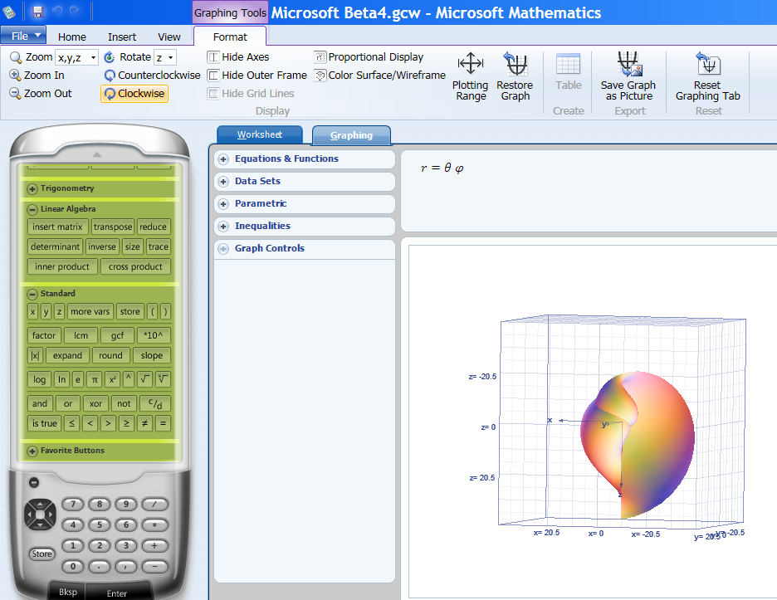
Figure 10: Microsoft Beta 4.0 interface.
6. CONCLUSION

ISTE’s public policy objectives are based on a core principle that technology is an essential element of teaching, learning, and instructional design in effective 21st-century learning systems [4]. As teachers embrace integrated lessons, there is an increase in student content acquisition [11]. “The way in which technology is used in a classroom is a critical measure of its success…When students and teachers perceive computers as a separate subject, unassociated with the context of the lesson or classroom, the content or concepts studied are often left fragmented in the learner’s mind. But if a technology-enhanced lesson is integrated into the larger curriculum with direct tie-ins, students are more likely to infuse the knowledge into existing cognitive structures” [1]. The Microsoft Mathematics Add-in for Microsoft Office Word 2007 and 2010 and Microsoft Mathematics Beta 4.0 makes it easy to create graphs, perform calculations, and solve for variables with equations and inequalities. The user-friendly interface allows for modeling and solving of complex problems with minimal syntax instruction. These are affordable and accessible computation tools that schools can quickly and widely adopt and one that students will embrace.

7. REFERENCES
[1] A. L. Baylor, & D. Ritchie, What Factors Facilitate Teacher Skill, Teacher Morale, and Perceived Student Learning in Technology-using Classrooms? Computers & Education, Vol. 39, No. 4, 2002, pp. 395 – 414.

[2] Committee on Appropriations, United States Senate, (1995). Educational Technology, Special Testimony, Washington, D.C.: U. S. Printing Office, April 4, 1995. http://www.eric.ed.gov/PDFS/ED393403.pdf

[3] S.C. Ehrmann, Asking the Right Question: What Does Research Tell Us About Technology and Higher Learning? Change, Vol. 27, No. 2, 1995, pp. 20-27.
[4] International Society for Technology in Education, ISTE’s U.S. Public Policy Principles and Federal & State Objectives, Washington, D.C.: ISTE, 2009. http://www.iste.org/Content/NavigationMenu/Advocacy/Policy/109.09-US-Public-Policy-Principles.pdf
[5] Microsoft Corporation, Microsoft Mathematics Beta 4.0, 2011: http://www.microsoft.com/downloads/en/details.aspx?FamilyID=9CACA722-5235-401C-8D3F-9E242B794C3A
[6] Microsoft Corporation, Microsoft Mathematics Add-In for Word and OneNote 2010: http://www.microsoft.com/downloads/en/details.aspx?FamilyID=CA620C50-1A56-49D2-90BD-B2E505B3BF09.
[7] National Council of Teachers of Mathematics (NCTM). Curriculum and Evaluation Standards for School Mathematics, Reston, VA: NCTM, 1989
[8] National Council of Teachers of Mathematics (NCTM). Principles and Standards for School Mathematics, Reston, VA: NCTM, 2000.
[9] A. Oldknow, (ed.) ICT and Mathematics: A Guide to Learning and Teaching Mathematics, Leicester: The Mathematical Association, 2005, pp. 11-19.
[10] J. Repka, Calculus with Analytic Geometry, Dubuque, IA: Wm. C. Brown, 1994.
[11] L.P. Rieber, & P.W. Welliver, Infusing Educational Technology into Mainstream Educational Computing, International Journal of Instructional Media, Vol. 16, No. 1, 1989, pp. 21-32.

[12] M. Shepard, A Rose is a Rose is a Rose…. The College Mathematics Journal, Vol. 28, No. 1, 1997, pp. 55-56.
[13] J. Stewart, Calculus, fifth edition, Belmont, CA: Thomson Learning, 2003

