ALGEBRA MODULE
Applications of the Animate Command for the Free Microsoft Word 2007 Math Add-In
This paper is designed to familiarize mathematics educators with the algebraic and symbolic capabilities of the free math add-in associated with Microsoft Word 2007. Special attention will be given to the power of the ‘animate’ command. This computer algebra system (CAS) is available as a free download to any legitimate institutional or individual license holder of Microsoft Word 2007. The add-in is a viable solution to schools that are challenged with budgets that do not support institutional investments for lab or site licenses for Mathematica, Maple, or graphing calculators. Additionally, schools that cannot currently trust students have access to graphing calculators outside of the classroom laboratory will benefit by engaging students with these powerful computational tools.
The Principles and Standards for School Mathematics (NCTM, 2000) states technology is essential in teaching and learning mathematics. “It influences the mathematics that is taught and enhances students’ learning” (p. 24). The goal for the mathematics classroom is one which calculators, computers, courseware, and manipulative materials are readily available and regularly used in instruction (NCTM, 1989) where “every student has access to technology to facilitate his or her mathematical learning” (NCTM, 2000). With the free software, a school writing or English laboratory can be turned into a mathematics laboratory.
The National Research Council (1989) report notes that “calculators and computers make new modes of instruction feasible at the same time that they inject into the learning environment a special sense of wonder which goes with healthy development of mathematical power.” In the activity of Edward’s (2009), he explores the power of a handheld calculator with a quadratic example; he outlines the procedure to create a ‘slider’ and shows the usefulness in providing an inquiry-based lesson. Within Word 2007, the animate (slider) command is set-up by default when graphing.
Getting Started
Download the free Microsoft Word 2007 Math Add-In (Microsoft, 2007).
Fig. 1 Inputting an equation to graph requires the add-in (a)

Fig. 1 Choose ‘Math’ (b)
Click the Add-Ins tab on the ribbon (see fig. 1a). Then click on the Microsoft Math button on the new ribbon (see fig. 1b).

Fig. 2 Insert new equation prompt (a).
Type an equation in the pop-up box (see fig. 2a). To begin, have students create a graph. An equation to demonstrate is quadratic (see fig. 2b).
Fig. 2 Sample input (b).
Right Click on the equation to bring up a content sensitive menu of mathematical options.
Fig. 2 Options displayed (c).
Select ‘Plot in 2D’ to bring up the Microsoft Math Graph Controls dialogue box (see fig. 2c).
Fig. 2 Graph of quadratic function (d).
It is that easy to generate a graph (see fig. 2d). Furthermore, the graph can be imported into a word processing document.
Examples Using the ‘Animate’ Feature in the Mathematics Curriculum
For the given example, select ‘Plot 2D’.
$$b\sin\left(x\right)=y$$
The ‘animate’ option will appear on the lower left part of the screen (see fig. 3a). Click on the right-arrow key to watch b increment from b = 0 to b = 2. As b increases, the amplitude increases and the graph on the screen changes. To stop midway, click on the right arrow again.
Fig. 3 Animate option appears by default (a).
To change the selection for b from b = -2 to b = 2, plug in -2 for the zero and see the graph rotate about the x-axis when b is positive.
For a similar example, the animate feature will involve a or b.
$$y=a*sin⁡(b*x)$$
Fig. 3 Animate command with two parameters (b).
Use the down- arrow key to bring up both parameters (see fig. 3b). Select a or b. Using technological tools, the Standards (2000) support students’ reasoning about more-general issues, such as parameter changes, which allows them to model and solve complex problems that were heretofore inaccessible (p. 26).
Teachers with ‘Smart’ boards can readily invent discovery lessons with an example such as:
$$\frac{x^{2}}{a^{2}}+\frac{y^{2}}{b^{2}}=1$$
Students quickly develop concepts and correctly guess the properties of the conic section with the briefest of directions while using ‘animate’ (see fig 4). Technology provides a focus as students discuss with one another and with their teacher the objects on the screen and the effects of the various dynamic transformations that technology allows (NCTM, 2000).
Fig. 4 Vary a or b to form ellipses or a circle.
Complex computations can be illustrated with the ‘animate’ command, also. The next example is the computation for the amortization of a fixed loan with level monthly payments. Students may substitute a constant for r based on a rate from their local bank. Let x represent time in years and p the amount of money financed, the value y for the monthly payment can be determined (see fig. 5). The “trace command” can give points on the curve.
$$y=\frac{p r}{12\left(1-{\left(1+\frac{r}{12}\right)}^{-12 x}\right)}$$
Fig. 5 The monthly payment for an amortized loan.
First year algebra students can be introduced to the concepts of slope and y-intercept (see fig. 6) by using animate with:
$$y=m x+b$$
Fig. 6 Discovery of slope and y-intercept concepts.
In both curricular content and instruction style, there “should be a renewed effort to focus on exploring patterns, not just learning formulas” (National Research Council, 1989).
‘Animate’ works in 3-D plots as well. One choice might be:
$$\frac{x^{2}}{a^{2}}+\frac{y^{2}}{b^{2}}+\frac{z^{2}}{c^{2}}=1$$
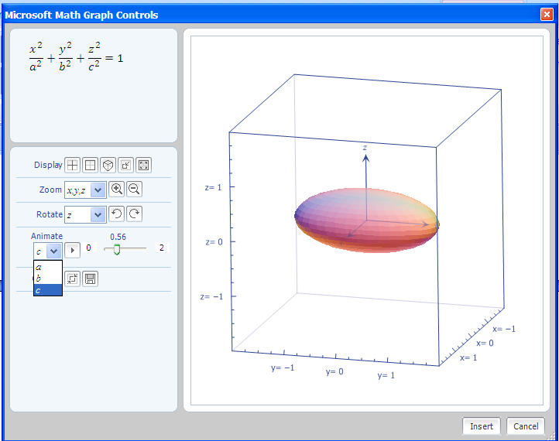
Fig. 7 Working with 3-D images.
Rotate the image about the x, y, or z axis for a moving picture (see fig. 7). Beforehand, teachers can provide a model in the classroom that they want simulated. The Professional Standards (1991) say that “mathematical power includes the ability to explore, conjecture, and reason logically” (p. 1).
Challenge your students to grasp extended concepts (see fig. 8) with the family of graphs such as:
$$\frac{x^{a}}{4}+\frac{y^{b}}{9}+\frac{z^{c}}{25}=1$$
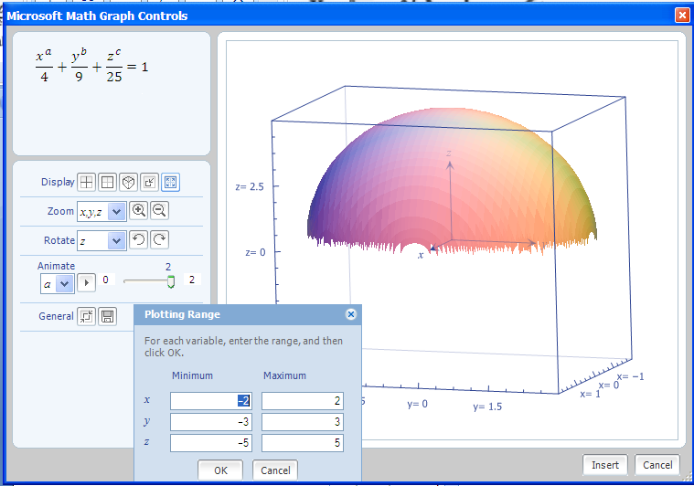
Fig. 8 Animate with parameters as exponents.
The Plot Range dialogue box can be activated by clicking on the last, right icon on the ‘Display’ line within the Microsoft Math Graph Controls dialogue box to control viewable octants.
Conclusion
The more specific reasoning habit of seeking patterns and relationships often receive limited attention in the classroom and whatever topics are taught, students must learn them in a way that deepens their mathematical thinking and reasoning (Martin, 2009). Technology can help with the students’ mathematical investigations.
“For example, with calculators and computers students can examine more examples or representational forms than are feasible by hand, so they can make and explore conjectures easily. The graphic power of technological tools affords access to visual models that are powerful but that many students are unable or unwilling to generate independently. The computation capacity of technology tools extends the range of problems accessible to students and also enables them to execute routine procedures quickly and accurately, thus allowing more time for conceptualizing and modeling” (NCTM, 2000, p. 25).
Graphing packages that allow for user defined interactions have arrived, and they have opened the door for mathematics teachers to vastly extend inquiry and discovery lessons. Teachers can opt for the ‘animate’ command in Word 2007, the ‘slider’ on a TI-Inspire, or the ‘manipulate’ command in Mathematica. Student understanding of concepts such as ‘amplitude’ and ‘period’ are enhanced by the use of these tools. But why stop there? Animate can be used to aid understanding of many topics throughout mathematics. Animate certainly adds to the number of concepts that students can readily discover for themselves.
Click here for additional college algebra presentation materials.

References
Edwards, Thomas G. and Asli Özgün-Koca, “Creating a Mathematical ‘B’ Movie: The Effect of b on the Graph of a Quadratic.” Mathematics Teacher 103, no. 3 (October 2009): 214-219.
Martin, Gary W. “The NCTM High School Curriculum Project: Why It Matters to You.” Mathematics Teacher 103, no. 3 (October 2009): 164-166.
Microsoft Word 2007 Math Add-In, http://www.microsoft.com/downloads/details.aspx?FamilyID=030fae9c-704f-48ca-971d-56241aefc764&DisplayLang=en
National Council of Teachers of Mathematics (NCTM). Curriculum and Evaluation Standards for School Mathematics. Reston, VA: NCTM, 1989.
National Council of Teachers of Mathematics (NCTM). Professional Standards for Teaching Mathematics. Reston, VA: NCTM, 1991.
National Council of Teachers of Mathematics (NCTM). Principles and Standards for School Mathematics. Reston, VA: NCTM, 2000.
National Research Council. Everybody Counts: A Report to the Nation of the Future of Mathematics Education, Washington, D.C.: National Academy of Sciences, 1989.
Smith, Karl J. The Nature of Mathematics. 11th ed. Belmont, CA: Thomson Brooks/Cole, 2007.
Stewart, James. Calculus. 5th ed. Belmont, CA: Thomson Learning, 2003.

