CALCULUS MODULE
FREE SOFTWARE AND MULTIVARIABLE CALCULUS

- INTRODUCTION

Calculators and computers make new modes of instruction possible; yet, at the same time they pose hardships for school districts and mathematics educators trying to incorporate technology with limited monetary resources. In the Standards, a recommended classroom is one in which calculators, computers, courseware, and manipulative materials are readily available and regularly used in instruction [2, p. 243]. This paper outlines a solution that is affordable for classrooms with computers but limited software availability. Special attention will be given to incorporating the free math add-in that is found in Microsoft Word 2007 into the calculus classroom. This paper gives specific examples highlighting the graphic and equation capabilities. However, the technology is not limited to this focus. Any license holder of Microsoft Word 2007 may download the software from www.microsoft.com. Hence, many students will have at home a mathematical tool that can be incorporated with word processing assignments.
- GRAPHING SURFACES
After downloading the math add-in, a Microsoft Math button will be added to the ribbon and have students use the Insert New Equation for an input [1]. See Figure 2.1.
Figure 2.1
The graph of the elliptic paraboloid z = $2x^{2}+y^{2}$ and its tangent plane $z=4x+2y-3$ when x = 1 and y = 1, can be graphed simultaneously [7, p. 960]. Students should insert each separately and then highlight jointly both equations by dragging using the left button on the mouse. The image shown is seen in Figure 2.2
Figure 2.2 Highlight.

Have students right click within the shaded region. The menu seen in Figure 2.3 will appear.

$$2x^{2}+y^{2}$$
$$4x+2y-3$$

Figure 2.3 Plot in 3D.

Alternatively, the Plot in 3D option appears after clicking on the down arrow at Math as shown in Figure 2.4. A pull down menu, as shown in Figure 2.5, will appear. Selecting Plot in 3D and the Rotate button captures a viewpoint that illustrates the plane is tangent to the curve as seen in Figure 2.6.

Figure 2.4 Math.

Figure 2.5 Plot in 3D.

Students may recognize that the surface is not defined below the x- y plane and is unbounded above. The sections parallel to the x-y plane are ellipses, where the sections parallel to the other coordinate planes are parabolas.

Figure 2.6 The graphs of z =$2 x^{2}+ y^{2}$and z = $4x+2y-3$

Students should consider a quadric surface which is a hyperboloid of one sheet such as, $z^{2}+ 1= x^{2}+y^{2}/4$. It can be graphed without the axes and units displayed by using the icons in the Display menu. Students should be directed to find the trace in the x-y plane is an ellipse and the traces in the other coordinate planes are hyperbolas as shown in Figure 2.7. The curve is rotated about the y-axis for a fine visual effect.

Figure 2.7 Hyperboloid of one sheet.

- CREATING A MOVIE USING TWO SURFACES
The next example will assume students understand the ceiling (or floor) function. A list of other functions may be found at: http://web02.gonzaga.edu/faculty/nord/wordusersmanual/builtinfunctions.docx
The command ceiling yields the right most integer for a given input. Similarly, the command floor yields an integer that is closest to the left of an input. If the input is an integer in either case, the output will be the original input value. For example, floor 3.22 = 3 and ceiling 3.22 = 4.
Students should discover that the Animate option appears by default in two-dimensions when using a letter other than x and y with Cartesian coordinates and r with polar coordinates. For three-dimension, using variables other than x, y and z will produce the Animate option. The variables, r, s, and t, are used to graph polar three-dimensional surfaces and curves and typically should not be used as an animation variable. The user is allowed to toggle values for the variable, such as a, that is defined. See Figure 3.1. Students may opt to play a movie, where the variable is allowed to increment in time.
The students have the tools now to create a customized movie where the picture oscillates back-and-forth from two quadric surfaces such as a hyperbolic paraboloid, $z=x^{2}-y^{2}/4$ and an elliptic paraboloid, $z=x^{2}+y^{2}/4$. The students will need to first define a variable, a, to animate on. The command ceiling a will always yield an integer. Therefore, ${(-1)}^{ceiling a}$ will take on only two values, -1 or 1 . After selecting Plot in 3D, have students select the domain for a. For larger values of a, the oscillation will increase. Let a =16 for example. The input the students should be able to realize that works is $z=x^{2}+{(-1)}^{ceiling a} y^{2}/4$. The two quadric surfaces that will alternatively appear will be a hyperbolic paraboloid, as shown in Figure 3.2, and an elliptic paraboloid.

Figure 3.1 Toggle values.

Figure 3.2 Create animation.

4. FURTHER GRAPHING FEATURES

Other features in the free math add-in include the capability to graph points, curves, and surfaces in two dimensions or three-dimensions using Cartesian, polar, parametric and cylindrical coordinates. Using Table 4.1, the students can be left to explore the many other graphing features and find patterns for the behavior of particular types of functions, curves, and surfaces. The absence, in some cases, of a command is permissible. The pull-down menu will have options such as Plot in 2D and Plot in 3D added for some examples, depending upon the input and the omission.

Command | Example | Notation Requirements | Drop- Down Menu Option to Execute
plot | $$plot(3*x^{2}+12*x)$$ | Input function, f(x). | Simplify
plot3D | $$plot3D(x+y^{3})$$ | Input where, z=f(x, y). | Simplify
plotCylDataSet3D | $$plotCylDataSet3D(\{\left\{1, 2, π\right\}, \left\{3,\frac{π}{2},\frac{3π}{2}\right\}\})$$ | Data point is {$r, θ,z\}.$ | Calculate
plotCylParamLine3D | $$plotCylParamLine3D(\cos\left(t\right),\sin\left(t^{2}\right), t^2)$$ | Insert $r=f\left(t\right), z=g\left(t\right), θ=h\left(t\right).$ | Simplify
plotCylR3D | $$plotCylR3D(r^{2}+\cos\left(3θ\right))$$ | Input z=f(r, $θ).$ | Simplify
plotDataSet | $$plotDataSet(\{\left\{2, 3\right\}, \left\{5, -1\right\}\})$$ | Input point, {x, y}. | Calculate
plotDataSet3D | $$plotDataSet3D(\{\left\{30, 2, 9\right\},\left\{-4, 8, 20\right\}\})$$ | Input point, {x, y, z}. | Calculate
plotEq | $$plotEq(x^{2}+y^{2}=9)$$ | Input f(x, y) = c. | Simplify
plotEq3D | $$plotEq3D(\frac{x^{2}}{4}+y^{2}+z^{2}=1)$$ | Input f(x, y, z)=c. | Simplify
plotIneq | $$plotIneq(x≤3+y)$$ | Input inequality in x and y. | Simplify
plotParam | $$plotParam(\sin{t, t^2)}$$ | Input (f(t), g(t))where x=f(t) and y=g(t). | Simplify
plotParam3D | $$plotParam3D(t+s, t+3s, t-s)$$ | Input (f(t, s), g(t, s),  h(t, s)) where x=f(t, s) and  y=g(t, s) and z=h(t, s). | Simplify
plotParamLine3D | $$plotParamLine3D(\cos{t, t+2, t)}$$ | Input (f(t), g(t), h(t)) where x=f(t) and y=g(t)and z=h(t). | Simplify
plotPolar | $$plotPolar(3×\sin{θ)}$$ | Input $r=f\left(θ\right).$ | Simplify
plotPolar3D | $$plotPolar3D(3θ-φ)$$ | Input $r=f(θ, φ)$. | Simplify
plotPolarDataSet | $$plotPolarDataSet(\{\left\{2,\frac{π}{3}\right\}, \left\{8, -\frac{π}{2}\right\}\})$$ | Input point {$r, θ\}.$ | Calculate
plotPolarDataSet3D | $$plotPolarDataSet3D(\{\left\{3,\frac{π}{2},π\right\},\left\{-2,\frac{π}{4},\frac{π}{4}\right\}\})$$ | Input a point, {$r, θ, φ\}.$ | Calculate
Table 4.1 Graphing in two dimensions and three dimensions.

An extension after the graphing exploration is to give a shape to the students, and have them find a way to resemble and create it graphically. For example, the shape given might be a tear-drop as shown in Figure 4.1 or a shell as shown in Figure 4.2. Students should be advised that solutions for a given shape are not necessarily unique.

Figure 4.1 Graph in parametric form of (sin (t), $t^{2}).$ $plotParam(\sin{t, t^2)}$

Figure 4.2 Graph in polar form of $r=3 θ-φ$.

Animate can be used to increase student understanding in parametric equations as well. A standard example of a graph of a helix (see Figure 4.3) is given:
$$plotParamLine3d(t,\sin\left(t\right),\cos\left(t\right),\left\{t,-10,10\right\})$$
Figure 4.3 A helix.
The graph of the helix uses the animate command; click on the animate slider bar and watch in real time as the helix acts like a spring undergoing compression and expansion (see Figure 4.4). Use the command:
$$plotParamLine3d(a t,\sin\left(t\right),\cos\left(t\right),\left\{t,-10,10\right\})$$
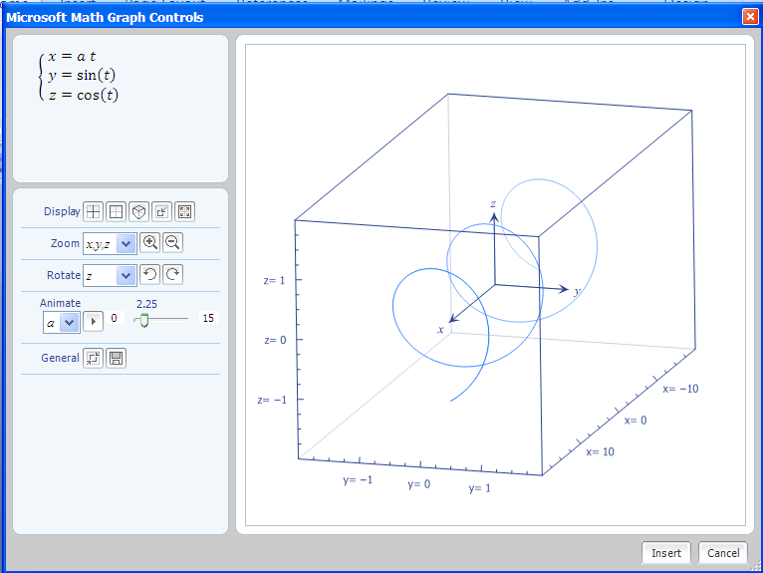
Figure 4.4 Spring.
Animate even works while plotting multiple simultaneous parametric equations in 3-D.
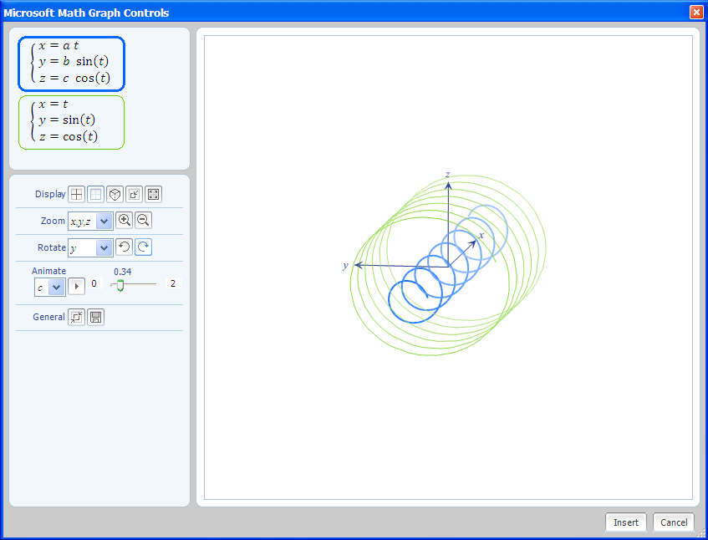
Figure 4.5 Two parametric equations graphed simultaneously.
These images were generated (see Figure 4.5) with the equation:
$$show3D(plotParamLine3d\left(a t,b sin\left(t\right),c cos\left(t\right),\left\{t,-20,20\right\}\right),plotParamLine3d(t,\sin\left(t\right),\cos\left(t\right),\left\{t,-20,20\right\})$$
The ‘Display’ options allow you to rotate and turn-off the grids as well.

For the calculus classroom, the next example will involve a function and its derivative. Left click to highlight both equations and right click and select ‘Plot 2D’. Animate on either a or b (see Figure 4.6). The graph of the line has an x-intercept where the parabola has a critical value.

$$y=a*x^{2}+b*x$$
$$y=2*a*x+b$$
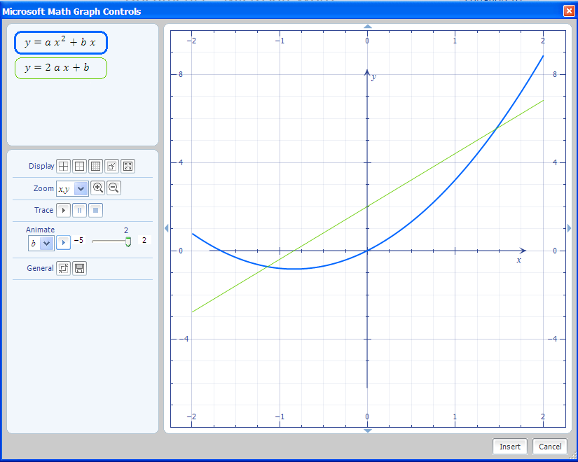
Figure 4.6 Change the parabola and its derivative.

5. EQUATIONS

The free math add-in can also be used by students to solve a single equation or a system of equations. An example involving a system of equations in a multivariable calculus course is as follows, ‘At what point do the curves, r₁(t)= <t,3+t²> and r₂(s)= <3-s,s²> ,intersect?’. Students may solve this problem numerically with the nsolve command. Consider the input:
$$nsolve(\left\{t=3-s, 3+t^{2}=s^{2}\right\})$$

A right click within the input line, followed by selecting Simplify from the pop-up window, yields the output:
$$\left\{\begin{aligned} t&≈1 \\ s&≈2\end{aligned}\right.$$

Alternative syntax involving the nsolve command will allow students to search specific interval(s) for specified variable(s) such as in the following example:
$$nsolve(\{x\sin{y}=\frac{1}{4},x-y=8\},\{\left\{x\right\},\left\{y,0,2π\right\}\})$$
The solution is:
$\left\{\begin{aligned} x&≈8.0311338842625 \\ y&≈0.0311338842625\end{aligned}\right.$ .
Microsoft Math allows changes to the preferences’ setting.
Figure 5.1 Math preferences.
For the previous example, Math Preferences was used to establish the angle in radian mode as shown in Figure 5.1. Real Numbers or Complex Numbers are also options that can be controlled.
The nsolve command can be used to solve problems with n-equations in n-unknowns.
Here the command:
$$nsolve(\left\{xsin\left(y\right)=z, x+y+z=20, x-y=2\},\{\left\{x\right\},\left\{y\right\},\left\{z,.3\right\}\right\})$$

produces the solution: $\left\{\begin{aligned} x&≈14.1098720475624 \\ y&≈12.1098720027676 \\ z&≈-6.2197440085919\end{aligned}\right.$.

The solution was obtained by inputting an initial value for the search on a particular variable, z. If a range or initial value is omitted in a problem, the search for the solution will be anywhere on the real number line.

Similarly, nsolve can be used to solve a linear system such as:

$$nsolve(\left\{x+y+z=3,x-y+z=2,x-y-z=-1\right\})$$

Notice that the answer is exact even though the output indicates an approximate solution.

$$\left\{\begin{aligned} x&≈1 \\ y&≈0.5 \\ z&≈1.5\end{aligned}\right.$$

Non-linear examples are also possible. An example of a non-linear problem along with its solution follows.
$$nsolve(\left\{xsin\left(y\right)=.5,x^{2}+y=10\right\})$$

$$\left\{\begin{aligned} x&≈3.1368650605934 \\ y&≈0.1600775916285\end{aligned}\right.$$

Consider the problem with a solution involving integers:

$$nsolve(\left\{x+y=2,x+z=2,y+z=2\right\})$$

The answer is, $\left\{\begin{aligned} x&≈1 \\ y&≈1 \\ z&≈1\end{aligned}\right.$.

Students can quickly produce graphs to check the feasibility of this solution by graphing the three planes as shown in Figure 5.2. Concurrent visualization always fosters understanding. Consider the input:
$$show3d(plotEq3d\left(x+y=2\right),plotEq3d\left(y+z=2\right),plotEq3d(x+z=2))$$

Figure 5.2 Three planes.

The show3D command allows the display of more than one three-dimensional curve using one input line. In conclusion, the nsolve command found within the Word Math Add-In always displays the result as an approximate solution, even though the solution may be exact. An allowable input should have the number of equations equal to the number of variables.
6. INTEGRALS

There are limitations to the software. Here is an example of a single variable integral it will not compute. The example input below yields an equivalent output:

$$\int_{1}^{5}{t\sqrt{t-1}} dt$$
$$\int_{1}^{5}{\sqrt{t-1} tⅆt}$$

At times, Word Math has difficulty working with square roots. The evaluation at t = 1 will involve a radicand which is zero, which appears to be the problem. Changing the value of t=1 to t=1.5 will create a problem that can be evaluated.

Input for multiple integrals can be accomplished by following these steps
First select the Integral tab as shown in Figure 6.1.

Figure 6.1 Integral tab.

To produce a definite integral, input values for a and b as shown below in Figure 6.2:

Figure 6.2 Set-up.

Then, select and apply the Integral command to the blue shaded region as shown in Figure 6.3.

Figure 6.3 Set-up a double integral.

The following double integral,

$$\int_{0}^{1}{\int_{0}^{x}{y}dy}dx$$

produces this output
$$\frac{1}{6}$$
A double integral such as:
$$\int_{0}^{\frac{π}{2}}{\int_{0}^{\sin{x}}{y}dy}dx$$

even yields a closed-form solution such as:
$$\frac{π}{8}$$

An example of a multivariable integral that will not produce a solution from within Word is:

$$\int_{1}^{5}{\int_{1}^{x}{\sqrt{y-1} dy}dx}$$

Mathematica (not a free technology) produces 128/15 as the answer. The problem with the radicand being zero still exists with double integrals.

Problems involving a u substitution are possible. Below is a problem with its answer.

$$\int_{12}^{x}{y \sqrt{y^{2}-1}ⅆy}$$

$$\frac{{\left(x^{2}-1\right)}^{\frac{3}{2}}-143 \sqrt{143}}{3}$$

See an application of the Fundamental Theorem of Integral Calculus on this example, by right clicking within the input line and selecting Differentiate on x as shown in Figure 6.4.
Figure 6.4 Differentiate on x.

The output is:

$$x \sqrt{x^{2}-1}$$

This tool offers students the ability to readily discover the Fundamental Theorem. A similar example illustrating a u substitution problem is as follows:

$$\int_{1}^{x}{y \sqrt[3]{y^{2}+1}ⅆy}$$

The correct output is:

$$\frac{3 {\left(x^{2}+1\right)}^{\frac{4}{3}}-3·2^{\frac{4}{3}}}{8}$$

There is an alternate way to evaluate definite and indefinite integrals by using the integral command. The integration constant is not included for some indefinite integrals. When considering an indefinite integral, input using the syntax:
integral(function, variable of integration)$.$ An indefinite integral example, $\int{\sqrt{y+1}dy}$, would have the input:
$$integral(\sqrt{y+1},y)$$
The output is:
$$\frac{2 {\left(y+1\right)}^{\frac{3}{2}}}{3}+С$$

To evaluate a definite integral, use the syntax:
integral(function, variable of integration, lower limit of evaluation, upper limit of evaluation). With more than a single integral, embed the integral symbol. The following example executes with the integral command, but does not execute without it. Consider the double integral, $\int_{3}^{5}{\int_{5}^{x}{\sqrt{y+1}dy}dx}$.
The executable input line is:
$$integral(integral\left(\sqrt{y+1}, y, 5,x\right),x, 3,5)$$

After selecting Simplify, the output is:
$$\frac{4·6^{\frac{5}{2}}}{15}-\frac{24 \sqrt{6}}{3}-\frac{128}{15}$$

As shown in Figure 6.5, right click and select Calculate.

Figure 6.5 Calculate command.

The output shows the second term has been simplified. Select Calculate again to give a numerical answer. Below is the double execution of the Calculate command with our original example.
$$\frac{4·6^{\frac{5}{2}}}{15}-8 \sqrt{6}-\frac{128}{15}$$
$$-4.6141497449$$

7. CONCLUSION

The use of the animate command and graphics are not limited to the topic of quadric surfaces as shown in sections 2 and 3. The Microsoft Word 2007 free math add-in can be used as a teaching and learning aid throughout the mathematics high school and undergraduate curriculum. As identified by the National Research Council [5, 84], “calculators and computers are not substitutes for hard work or precise thinking, but challenging tools to be used for productive ends.” The computation capacity of technology tools extends the range of problems accessible to students [4, 25]. The free math add-in provides an available option as a computer algebra system that will enhance student learning.
The Microsoft Word Math Add-In and MathType are not compatible. If MathType is installed concurrently on the computer, the Add-In will function intermittently or not at all. The MathType software may be temporarily disabled by following the instructions found at, http://web02.gonzaga.edu/faculty/nord/wordusersmanual/troubleshooting.docx.
For extended examples, links to downloads, and materials appropriate for other mathematical curricular topics, see: http://web02.gonzaga.edu/faculty/nord/links.htm.

8. REFERENCES

1. Microsoft Word 2007 Math Add-In, http://www.microsoft.com/downloads/details.aspx?FamilyID=030fae9c-704f-48ca-971d-56241aefc764&DisplayLang=en
2. National Council of Teachers of Mathematics (NCTM), Curriculum and Evaluation Standards for School Mathematics, NCTM, Reston, VA, ISBN 0-87353-273-2 (1989).
3. National Council of Teachers of Mathematics (NCTM), Professional Standards for Teaching Mathematics, NCTM, Reston, VA, ISBN 0-87353-397-0 (1991).
4. National Council of Teachers of Mathematics (NCTM), Principles and Standards for School Mathematics, NCTM, Reston, VA, ISBN 0-87353-480-8 (2000).
5. National Research Council, Everybody Counts: A Report to the Nation of the Future of Mathematics Education, National Academy of Sciences, Washington D.C., ISBN 0-309-03977-0 (1989).
6. S. Salas, E. Hille, and G.J. Etgen, Calculus One and Several Variables, Eighth Edition, John Wiley & Sons, NY, ISBN 0-471-31659-8 (1999).
7. J. Stewart, Calculus. Fifth Edition, Thomson Learning, Belmont, CA, ISBN 0-534-27408-0 (2003).

