Solving Algebraic Equalities using “Plot Both Sides in 2D” and “Solve for x” with Microsoft Word
Utilize the techniques demonstrated in the examples to complete the problems that follow.
Example 1: Solve $\sqrt{3+x}=4$ by squaring both sides.
Solution:
$$\sqrt{3+x}=4$$
$$3+x=16$$
$$x=13$$
Example 2: Solve $\sqrt{5-2 x}+2=7$ by graphing.
Solution:
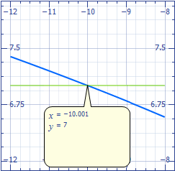
Example 3: Solve $\sqrt{x+12}+\sqrt{x}=\sqrt{9x}$ by squaring both sides and by graphing.
Solution:

$$\sqrt{x+12}+\sqrt{x}=\sqrt{9x}$$
$$\sqrt{x+12}=\sqrt{9x}-\sqrt{x}$$
$$\sqrt{x+12}=3\sqrt{x}-\sqrt{x}$$
$$\sqrt{x+12}=2\sqrt{x}$$
$$x+12=4x$$
$$x=4$$
Problems
Directions: Solve each for ‘x’ below using both the “Plot” and “Solve” commands.
1 a $\sqrt{5-x}=6$
b $\sqrt{3+2x}+1=9$
c $6\sqrt{2-x}=15$
d $5-\sqrt{4+x}=7$
2 a $\sqrt[3]{x+2}=5$
b $\sqrt[4]{2-3x}=2$
c $\sqrt[3]{5-x/2}=3$
3 a $\sqrt{7x}-\sqrt{x+2}=4$
b $x-3=\sqrt{2x-1}$
c $\sqrt{2x+5}+5=\sqrt{2x}$
d $\sqrt{{\left(x-4\right)}^{2}+y^{2}}+\sqrt{{\left(x+4\right)}^{2}+y^{2}}=10$

