Graph Options
Animate Command
Examples of polar graphs in two-dimensions
Consider the graphs of the roses generated by:
$r=cos⁡(n θ)$ .
The graphics package found within the math add-in takes the command syntax:
$plotPolar\left(\cos\left(nθ\right),\left\{θ, 0, 2π\right\}\right)$ .
The content sensitive ‘right click’ generates a mathematical operations menu that contains, Simplify. Animate appears as an option in the pop-up Microsoft Math Graph Controls dialogue box. Animate can be used to generate a movie of different roses as n changes, or n can be directly controlled by changing the value of the upper limit on the right of the animate control panel that allows input for a fixed value as shown in Figure 1.
Figure 1: a rose where n is fixed for the frame
The students can interact with the upper limit to generate real-time examples and quickly seize upon the theorem for roses. The number of petals is n if n is odd and 2n if n is even where $r=\sin{nθ}$ or $r=\cos{nθ}$ [6]. The plotPolar command can be absent, and an example using $r=\sin{nθ}$ is given in Figure 2 using the Plot in 2D option from the pull-down screen. The input can merely be $\sin{nθ}$ followed by a right click. The input does not require multifaceted syntax. The animate command will appear by default with the introduction of the variable, n.
Figure 2: creating a movie with the right arrow key
Cardioids and limaçons can easily be treated with the same student interest generated by the Animate command. Apply the Simplify option from the command, $plotPolar(a+b cos⁡(θ),\left\{θ, 0, 4π\right\})$ and generate a graph with default values a = b = 1. For example, b=1, when animating on a. It is possible to introduce more than one variable for utilization of the animate feature.
Figure 3: cardioid
Students can discover that $r=a+bcosθ$ is the graph of a cardioid if |a| =|b| as shown in Figure 3. Otherwise, the graph is a limaçon that has two loops if |a| <|b|, dimpled if 1 < |$\frac{a}{b}$| $<$2, and convex if |$\frac{a}{b}$|$≥$ 2 [6].
Several real-time examples involving the ‘play’ button will lead students to conjecture and test assumptions about the relationships between parameters a, and b, and the resulting graphs. Serious students looking for extensions, or explorations, can be left to discover relationships between graph types when parameters, a, b, and n, vary with the equation of $r=a+bcos nθ$ $.$ The speed of computers enables students to produce many examples when exploring mathematical problems; this supports their observation of patterns and the building and justifying of generalizations [5].

Examples of polar graphs in three-dimensions
The free math add-in found in Microsoft Word 2007 can also generate three-dimensional polar images, using spherical coordinates. An example of the syntax for three-dimensional polar graphs is,
$plotPolar3D\left(\cos\left(3θ\right)\sin\left(2φ\right), \left\{θ, π, 3π\right\}\right)$ .
The image is shown in Figure 4.
Figure 4: a three-dimensional image
The National Council of Teachers of Mathematics Curriculum Standards (1989) encourages the use graphing utilities to investigate informally the surfaces generated by functions of two variables. “Such investigations not only contribute to further development of important visualization skills but also foreshadow more advanced work with functions.”
An application of the animate command to three-dimensional polar graphs could entail using
$plotPolar3D\left(\cos\left(aθ\right)\sin\left(bφ\right), \left\{θ, π, 3π\right\}\right)$or$plotPolar3D(φcos\left(aθ\right), \left\{θ, 0, 3π\right\},\{φ,0,π\})$. Similarly, the option of omitting the plotPolar3D syntax is permitted. The equation r = f($θ,φ)$ can be inserted and the use of the command Plot in 3D can be applied from the menu.
The graph generated by the math Word command, $plotPolar3D\left(θφ, \left\{θ, 0, 3π\right\},\left\{φ,0,π\right\}\right),$ is the spherical coordinates three-dimensional analog to the spiral of Archimedes as seen in Figure 5 [6]. It might be very difficult to draw an example resembling a chambered nautilus on the chalkboard of this quality. Students should use the Rotate option to revolve the surface around the x, y, or z axis. In addition, the Zoom feature allows for further interactive investigation. Having students use computers to manipulate pictures dynamically, encourages them to visualize the geometry as they generate their own mental images [5].

Figure 5: image of a shell that resembles a chambered nautilus
Selected graphing commands
Table 1 contains a selection of graphing commands designed to demonstrate the versatility and power of the software. Flexible input allows for alternative syntax. For example, $plot(4x^{2}+12x+2)$ followed with a right click and the selection of Simplify will produce the graph of a parabola. Alternatively, the input of the expression, $4x^{2}+12x+2$ , or the equation, $y=4x^{2}+12x+2$, followed with a right-click and the selection of Plot in 2D all yield the identical graph.

Graph Options
Graphing Commands
Table 1: other features
Command | Example | Input
plot | $$plot(4x^{2}+12*x+2)$$ | Input function, f(x).
plot3D | $$plot3D(2x+y^{3})$$ | Input where, z=f(x, y).
plotCylDataSet3D | $$plotCylDataSet3D(\left\{\left\{2, 1, 5\right\},\left\{5,\frac{π}{3},1\right\}\right\})$$ | Data point is {$r, θ,z\}.$
plotCylParamLine3D | $$plotCylParamLine3D(2t{,\sin\left(t^{2}\right), 2t)}$$ | Insert $r=f\left(t\right), z=g\left(t\right), θ=h\left(t\right).$
plotCylR3D | $$plotCylR3D(r^{2}+\sin\left(2θ\right))$$ | Input z=f(r, $θ).$
plotDataSet | $$plotDataSet(\{\left\{2, -7\right\}, \left\{-1, -12\right\}\})$$ | Input point, {x, y}.
plotDataSet3D | $$plotDataSet3D(\{\left\{20, 0, 19\right\},\left\{-6, 12, 22\right\}\})$$ | Input point, {x, y, z}.
plotEq | $$plotEq(x^{2}+y^{2}=4)$$ | Input f(x, y) = c.
plotEq3D | $$plotEq3D(\frac{x^{2}}{9}+y^{2}+z^{2}=1)$$ | Input f(x, y, z)=c.
plotIneq | $$plotIneq(2x≤3+3y)$$ | Input inequality in x and y.
plotParam | $$plotParam(\sin{t, 3t-5)}$$ | Input (f(t), g(t)) where x=f(t) and y=g(t).
plotParam3D | $$plotParam3D(t+s^{2}, t+3s, t-s^{2})$$ | Input (f(t, s), g(t, s),  h(t, s)) where x=f(t, s) and  y=g(t, s) and z=h(t, s).
plotParamLine3D | $$plotParamLine3D(\cos{(3t), t+5, t^{3})}$$ | Input ( f(t), g(t), h(t)) where x=f(t) and y=g(t)and z=h(t).
plotPolarDataSet | $$plotPolarDataSet(\{\left\{14,\frac{π}{3}\right\}, \left\{8, -\frac{π}{3}\right\}\})$$ | Input point {$r, θ\}.$
plotPolarDataSet3D | $$plotPolarDataSet3D(\{\left\{3,\frac{π}{6},π\right\},\left\{29,\frac{π}{2},\frac{π}{8}\right\}\})$$ | Input a point, {$r, θ, φ\}.$

To execute these commands using the drop-down menu, apply Calculate or Simplify.

Example 1: Use the plotParam3D command.
Input:
$$plotParam3D\left(\cosh{s\cos{t,\sin{s\cos{t,\sin{t}}}}}\right)$$
Output:
Example 2: Use the plotparamline3d command.
Input:
$plotparam3d(\cos{t ,\sin{t, \cos{t\sin{st)}}}}$
Output:

Example 3: Sketch the intersection of two cylinders, x²+y²=1 and z²+y²=1.
Input:
$plotparamline3d(\cos{t,\sin{t,\cos{t)}}}$
Output:
Using the show3d command, plotting the two cylinders on the same axes is possible using one input line.
Input:
$$show3d\left(Ploteq3d\left(x^{2}+y^{2}=1\right),ploteq3d\left(z^{2}+y^{2}=1\right)\right)$$
Output:

Example 4: Use the plot3d command.
Input:
$$plot3d(\sqrt[3]{x^{3}+y^{3}})$$
Output:

References
- International Society for Technology in Education (ISTE) (2009). ISTE’s U.S. Public Policy Principles and Federal & State Objectives. Washington, D.C.:
http://www.iste.org/Content/NavigationMenu/Advocacy/Policy/109.09-US-Public-Policy-Principles.pdf
- Microsoft Corporation, Word 2007 Math Add-In: http://www.microsoft.com/downloads/details.aspx?familyid=030FAE9C-704F-48CA-971D-56241AEFC764&displaylang=en.
- National Council of Teachers of Mathematics (NCTM) (1989). Curriculum and Evaluation Standards for School Mathematics. NCTM, Reston, Virginia.
- National Council of Teachers of Mathematics (NCTM) (2000). Principles and Standards for School Mathematics. NCTM, Reston, Virginia.
- Oldknow, A. (ed.) (2005). ICT and Mathematics: a guide to learning and teaching mathematics 11-19. The Mathematical Association, Leicester.
- Repka, J. (1994). Calculus with Analytic Geometry. Wm. C. Brown, Dubuque, Iowa.
- Riddle, D. (1984). Calculus and Analytic Geometry. fourth edition, Wadsworth, Belmont, California.
- Shepard, M., (1997). A rose is a rose is a rose…. The College Mathematics Journal, 28 No 1, 55-56.
- Stewart, J. (2003). Calculus. fifth edition, Thomson Learning, Belmont, California, 2003.
- Thomas, G. and Finney, R. Calculus and Analytic Geometry, 9th edition, Addison-Wesley, Reading, Massachusetts, 1996.

Graph Options
Show and Show3D commands
Use the Show command when working in two dimensions. Use the Show3D command when working in three dimensions. The show and show3d commands are used to input more than one curve/surface with one input line. The multiple curves/surfaces will appear graphed together. Separate each curve/surface with a comma.
Example 1: Give an example using the show3d command and the plot3d command.
Input:
$$show3D(plot3d\left(y^{2}-x^{2}\right),plot3d\left(x^{2}+y^{2}\right))$$
Output:
Change the scale here for specific values.
Change the scale.

Change the scale if you want by using the last two buttons in the Display row. A new window yields:
After right-clicking on the input line, select Simplify from the menu to bring up the graph.
Example 2: Give an example using the show3d command and the plotparamline3d command.
Input:
$$show3d(plotEq3D\left(x^{2}+y^{2}+z^{2}=1\right), plotparamline3d(\cos{t,\sin{t,\cos{t)}}})$$

Output:
Example 3: Give an example using the show command, the plot command, and the deriv command.
Input:
$$show(Plot\left(x^{3},\left\{x,-5,5\right\}\right),Plot(deriv\left(x^{3},x\right),\left\{x,-5,5\right\})$$
Output:
Example 4: Give an example using the show command, the plot command, and derivn command. (The derivn command is used when considering a nth derivative.)
Input:
$$show(Plot\left(x^{3},\left\{x,-5,5\right\}\right),Plot(deriv\left(x^{3},x\right),\left\{x,-5,5\right\}),Plot(derivn\left(x^{3},x,3\right),\{x,-5,5\})$$
Output:
Example 5: Give an example using the show3d command, the plot3d command, and the animation feature.
Input:
$$show3D(Plot3D\left(1-{ax}^{3}\right),Plot3D\left(3x^{2}+4y\right))$$
Output:

Graph Options
Restricting Domain
Restrict the domain using this format: {variable, minimum value,maximum value}.
Example 1: Give an example restricting the domain and use the plot3d command.
Input:
$$plot3D\left(x^{2}+y^{2},\left\{x,0,4\right\},\left\{y,0,6\right\}\right)$$
Output:
Example 2: Give an example restricting the domain and use the plot3d command and the show3d command.
Input:
$$show3d(plot3D\left(x^{2}+y^{2},\left\{x,0,4\right\},\left\{y,0,6\right\}\right),plot3D\left(x-y,\left\{x,4,10\right\},\left\{y,6,12\right\}\right))$$
Output:

Example 3: Give an example restricting the domain where a variable is defined for negative real numbers and use the plot3d command and the show3d command.
Input:
$$show3d\left(plot3D\left(x^{3}-y^{3},\left\{x,0,8\right\},\left\{y,-6,6\right\}\right),plot3D\left(x^{4}-y^{3},\left\{x,-5,0\right\},\left\{y,-5,5\right\}\right)\right)$$
Output:
Example 4: Give a graphing example involving a radical. In addition, restrict the domain, use the plot3d command, and the show3d command.
Input:
$$show3d(plot3D\left(x^{3}-y^3,\left\{x,0,8\right\},\left\{y,-6,6\right\}\right),plot3D\left(\sqrt[5]{x^{4}-y^15},\left\{x,-5,0\right\},\left\{y,-5,5\right\}\right))$$
Output:

Graph Options
Labeling Axes
Use the command alias followed by a variable to label a specific axis. The example, {aliasy,profit}, labels the y-axis as profit.
Example 1: Give an example using the show command and plot command. Label the y-axis, ‘Profit’.
Input:
$$show\left(Plot\left(x^{2},\left\{x,0,4\right\}\right),Plot\left(2x,\left\{x,4,10\right\}\right),\left\{Aliasy,\text{Profit}\right\}\right)$$
Output:
Example 2: Give an example labeling the x-axis as Time and the y-axis as Profit.
Input:
$$show\left(Plot\left(2x,\left\{x,4,10\right\}\right),\left\{aliasy,\text{Profit}\right\}, \{aliasx,Time\}\right)$$
Output:

Use the Zoom feature to zoom in and out. The labeling of the axes are visible after zooming out. Notice the variable x is defined in the equation as Time and the variable y is defined in the equation as Profit.
Zoom out.
Zoom in.

Graphic Options
Color Options
When more than one graph is created, the Microsoft Word Math Add-In sets each graph a different color by default. It is possible to specify a particular color for a curve/surface. Specify the color using the format, {color,”RGB number”}. Double quotes are needed with the RGB number.
The RGB number represents three two digit numbers in base 16 (with no spaces or commas). A base 16 (hexadecimal) possible digits are 0, 1, 2, 3, 4, 5, 6, 7, 8, 9, a, b, c, d, e, and f. The smallest two digit number in base 16 is 00 and the largest is ff. Three two digit numbers (base 16) represent the RGB (red, green, and blue) intensity respectively. The three two digit numbers ff2200 will specify orange. Using this notation of the RGB number being ff2200, the intensity of red is increased, the intensity of green is small, and the intensity of blue is the smallest.
In addition, the shade of a color can be controlled. If two digits are added in front of the RGB number, the shading of the color can range from being transparent (disappear) to bold. The two digit hexadecimal number 00 will display an invisible graph. The two digit hexadecimal number ff will display the color in bold form. If no shade of the color is specified, the color will be in bold form.
Example 1: Give an example of a graph that will have the color orange.
Input:
$$plot(\cos{2x,\{color,"\text{ff2200"}\})}$$
Output:

Example 2: Give an example of a graph that will have the color light orange.
Input:
$$plot(\cos{2x,\{color,"44\text{ff2200"\}})}$$
Output:

Example 3: Give an example using the show3d command and specify a color for one of the curves.
Input:
$$show3d(plotEq3D\left(x^{2}+y^{2}+z^{2}=1\right), plotparamline3d(\cos{t/\cosh{at},\sin{t/\cosh{at},\sinh{at /\cosh{at,\left\{t, -4 π, 4 π\right\},\{color, "\text{ff0000"}\})}}}}$$
Output:

In the example, the color of the loxodrome was established to be displayed in red by setting the RGB number to be ff0000 (Nord and Miller, 1996). The intensity of red was increased and the intensity of green and blue were set to the lowest possible numbers. The unit sphere was displayed in a mesh (skeleton) form by using the third button in the Display row.
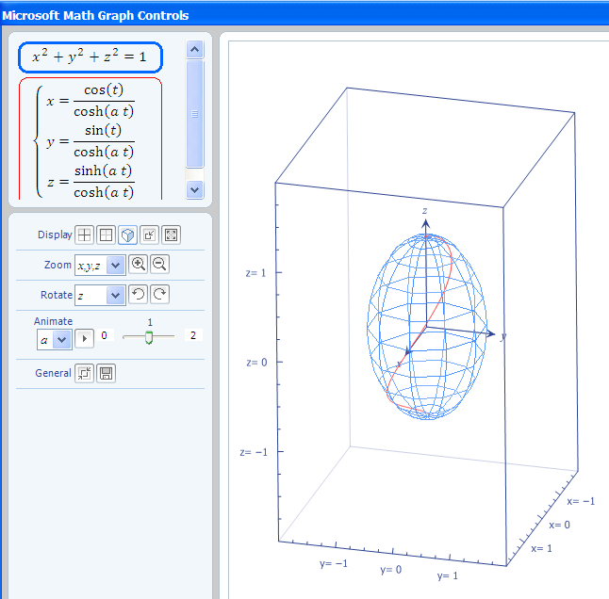
Create a skeleton (mesh) of the curve.

The Microsoft Math Graph Controls box can be omitted by selecting the first button in the General row. The second button will save the image. Below is the output after selecting the first button.

Graphs that are not displayed in the mesh (skeleton) mode may also be saved and inserted into documents, also. An example is shown below.
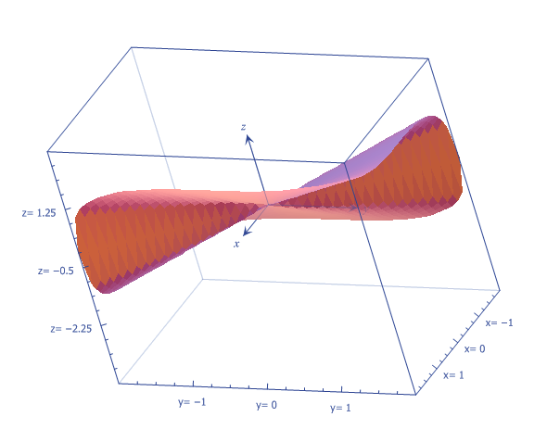

Graph Options
Line Styles
Equations and inequalities are plotted as solid lines (or curves) by default. The following are line styles:
- Solid
- Dot
- Dash
- Dashdot
- Dashdotdot
The format to indicate a line style is {linestyle,”type”}. Use the recognized command, linestyle, and the double quotation marks.
Example 1: Give an example using the line style “dot” in a graphing problem.
Input:
$$plot(\cos{2x},\left\{linestyle,"\text{dot"}\right\})$$
Output:
Example 2: Give an example using the line style “dashdotdot” in a graphing problem.
Input:
$$plot(\cos{2x},\left\{linestyle,"\text{dashdotdot"}\right\})$$
Output:

References:
Nord, J. and Miller, E. "Mercator's Rhumb Lines," The College Mathematics Journal, Mathematical Association of America, Vol. 27, No. 5, November 1996,pages 384-387.
Thomas, G. and Finney, R. Calculus and Analytic Geometry, 9th edition, Addison-Wesley, Reading, Massachusetts, 1996.
Zill, Dennis G. and Cullen, Michael R. Advanced Engineering Mathematics, 3rd edition, Jones and Bartlett Publishers, Massachusetts, 2006.
http://mathworld.wolfram.com/SphericalSpiral.html

Graph Options
Embed a Graphical Image
Embed a Graphical Image
Consider the 3-D surface, $x^{2}-4y^{2}=z$.
Right click below and select Plot in 3D.

$$x^{2}-4y^{2}$$
To embed a cropped graphical image for our example, follow these steps.
1. Select Print Screen from the top row of your computer keyboard.
2. To copy this image select Ctrl followed with c. This will copy the image.
3. Close the window of the graphing image. There is an “X” on the top right of the image.
4. Paste the desired image at a specific location within the Word document. Select Ctrl followed with a p. This will paste the image.
Below is our example:
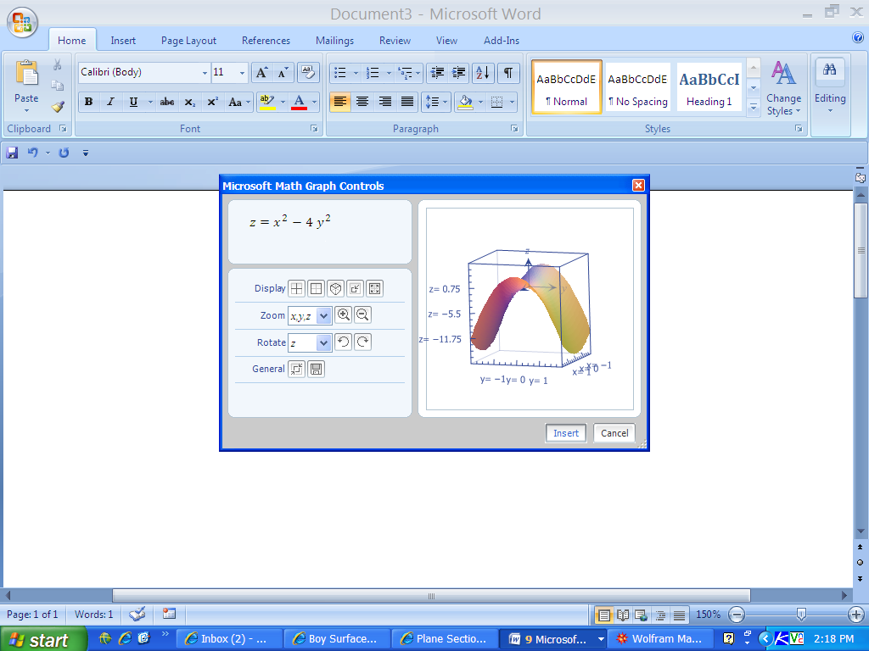

5. Double-click somewhere within the graphing image.
6. Locate Picture Tools that now appears above Format on the top-most ribbon.
7. Select Crop. It now appears on the top right-hand side of the ribbon. It was must be selected before any cropping of the image can occur. The corners will appear in black.
8. Place the cursor in the bottom right corner of the original image. Each corner will appear as shown below. The example below is a bottom left corner.
Point and click and drag the piece off you wish. The bottom of our original image has been cropped.

Crop from this corner in the next step.

9. Repeat the steps to crop the top part of our image. Double click on the image. Select Crop. Now, place the cursor at the top left corner. Point and click and drag the piece off you wish here.
The resulting desired image is below:

