More Information

http://www.microsoft.com/math/default.mspx
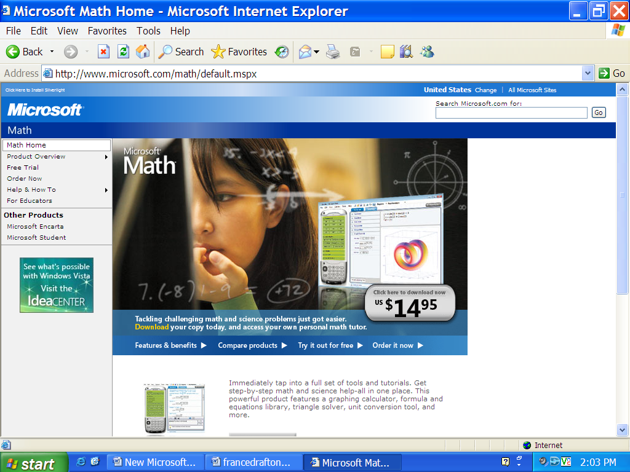

http://www.microsoft.com/downloads/details.aspx?FamilyID=030fae9c-704f-48ca-971d-56241aefc764&DisplayLang=en

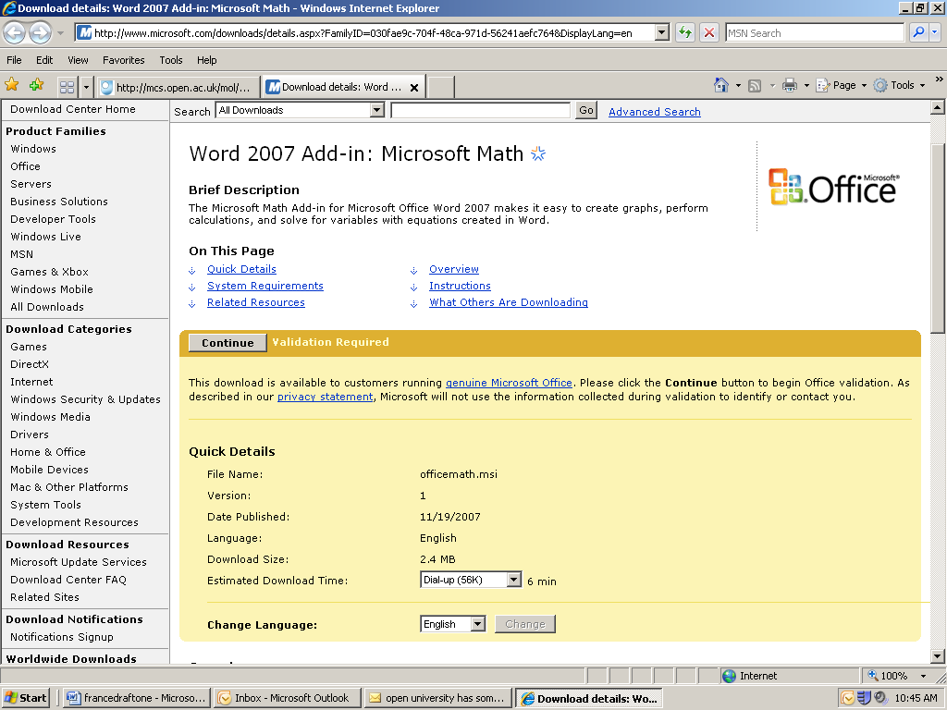

http://mcs.open.ac.uk/mol/Mathematical_features_of_Word2007.pdf

