Statistics and Probability
Normal Distribution
The free Add-In will not evaluate something as difficult as:
$$\frac{1}{\sqrt{2 π}}\int_{0}^{1}{e^{-x^{2}/2}}dx$$
The choices in the menu telegraph the mathematical abilities based on available options. Notice below that, “Integrate” is not among the choices when I highlight this function.
$$e^{{-x}^{2}}$$

Statistics and Probability
Binomial Random Variable
$\sum_{k=1}^{6}{\left({6 \atop k}\right)}$ yields $\frac{147}{10}$
This appears to be a standard mathematical notation for combinations. However, the sum given is wrong. The pre-programmed notation must indicate a sum of rational numbers and not combinations as evidenced by the results produced in the examples.
$\left({6 \atop 5}\right)$ yields $\frac{6}{5}$
Word has a number of “Built-In” functions. Use these with caution! They appear to have been designed more for text convenience and less for mathematical usefulness.
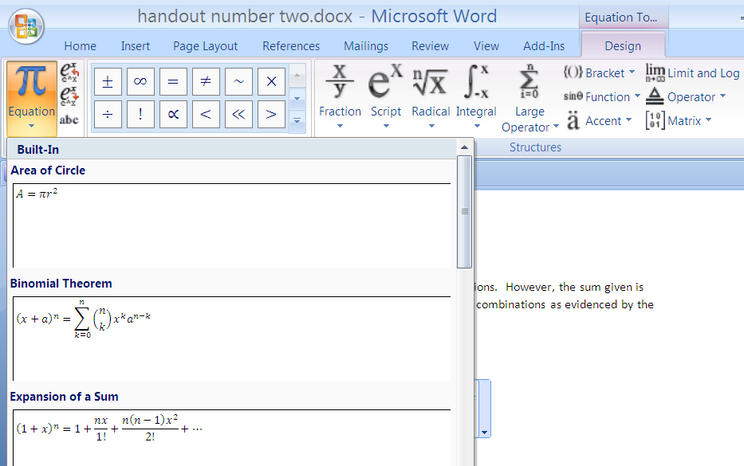
The examples generated above came about by editing the text from this built-in function.
$${\left(x+a\right)}^{n}=\sum_{k=0}^{n}{\left({n \atop k}\right)x^{k}a^{n-k}}$$

Statistics and Probability
Examples
Enter a string of numbers using “{“ and “ }” and separate each element with a comma.
Example 1. Consider the following and right click on the string:
$$\{2, 3, 2, 0, 3\}$$

Select ‘Calculate Statistic” to bring up a list of options where you can operate on the string.

The variance command will assume the denominator used is equal to the sample size, n, and not n - 1. Caution should be used here when calculating the sample variance. You will receive a biased variance for this list (string).
$$\{2, 3,2, 0, 3\}$$
The biased variance that is calculated for our example will be 6/5 and not 6/4 or 3/2. Use the command ‘UnbiasedVariance” to receive the output 3/2.
$$UnbiasedVariance\{2, 3, 2, 0, 3\}$$

To get an unbiased sample standard deviation use the input:
$$unbiasedStdDev\{2, 3, 2, 0, 3\}$$

Example 2. Find the sample correlation coefficient from a sample of 8 data points.
The data points will be (2.1, 1.38), (3.1, 2.14), (4.2, 1.84), (3.1, 1.61), (2.5, 2.09), (3.0, 1.79), (4.9, 2.15), (2.9, 1.68).
I will generate a list that represents the x-coordinates. I will generate a second list for the y-coordinates. Use “{“ and “}” to consider each to be a list (string). Separate the two lists with a comma. Use the command “correlation”. For our example, the command will be:

$$correlation(\left\{2.1, 3.1, 4.2, 3.1, 2.5, 3.0, 4.9, 2.9\right\}, \left\{1.38, 2.14, 1.84, 1.61, 2.09, 1.79, 2.15, 1.68\right\})$$
After inserting this as the new equation and right clicking, select the option “calculate”.
The answer will be:
$$\frac{182 \sqrt{3102635}}{620527}$$
Select “calculate” again from the previous output to find the sample correlation coefficient, r, as a decimal.
$$0.5166257498591$$
Example 3. Graph the standard normal curve.
State the function, highlight the input, and right click. Select “Plot 2D”. The default setting is that the input below is equal to y or f(x).
The function and its graph are the following:

$$\frac{1}{sqrt(2×π)} ×e^{-x^{2}/2}$$

Example 4. Find the combination 5 choose 2. Use the command “combination”. Right click on the equation line and select “Calculate”.
$$combination(5,2)$$
The output will be:
$$10$$

Example 5. Find the permutation 5 permute 2. Use the command “permutation”. Right click on the equation line and select “Calculate”.
$$permutation(5, 2)$$
The output will be:
$$20$$
Example 6. Find 5 factorial. Use the command “!”. Right click on the equation line and select “calculate”.
$$5!$$
The output is:
$$120$$
Example 7. Find the binomial coefficients where n=8. Find all values ₈C_{k}, where k is an integer assigned zero to eight.
Enter the command “combination” followed by a comma and then a string of possible values for k.
$$combination(8, \left\{0, 1, 2, 3, 4, 5, 6, 7, 8\right\})$$
Press “Calculate” to receive the output from a row of Pascal’s Triangle:
$$\left\{1, 8, 28, 56, 70, 56, 28, 8, 1\right\}$$
Example 8. Assume a binomial random variable with p=.20, q=.80, and n=10. Calculate the probability of exactly 3 or less successes from a trial size of 10.
Use the notation command of “combination” to denote a combination, and make sure the curser is in the appropriate location to denote an exponent. Highlight this expression and right click.
$$\sum_{k=0}^{3}{combination \left(10,k\right)*{.2}^{k}}*{.8}^{10-k}$$
Press “Simplify” to show the probability.

$$0.8791261184$$
Example 9. Assume a poisson random variable where $λ$=5.0. Find the probability of exactly 3 or less successes.
First, key in the expression and highlight.
$$\sum_{y=0}^{3}{e^{-5}×5^{y}÷y!}$$
Select “Simplify”. The answer is not written as a decimal.

$$\frac{118}{3 e^{5}}$$
Highlight and press “Calculate” on the output to yield the desired probability.
$$0.2650259152974$$
Example 10. Use a random number generator to simulate a roll of a fair die. State the outcome.
The command “ceiling” yields the right most integer for a given input. Similarly, the command “floor” yields an integer that is closest to the left from a given input. If the input is an integer in either case, the output will be the original input value. Use the “ceiling” function for our example. The command “random()” yields a random number from zero to one. A random number between zero and six would use the command, random(6). Similarly, a random number between zero and four is generated with the command, random(4). Our input for our example should be,
$$ceiling(random\left(6\right))$$
Right click on the input, and select, “Calculate” from the pull-down menu. One example output might be 4.

